ECS 3361: Social Issues and Ethics in

ECS

# Lecture 2 Introduction to Ethics Chapter 2

Credits:

Dr. Michael J. Quinn, Author of “Ethics for the information age The Free Encyclopedia, [http://en.wikipedia.org](http://en.wikipedia.org/) YouTube

# Today’s Learning Objectives

• Introduction • Review of nine ethical theories • Comparing workable ethical theories • Morality of breaking the law • Homework 2

# Introduction

## • We share “innate core values” of

* Life
* Happiness
* Ability to choose and accomplish goals

## • Two points of view

* Selfish: Consider only your own self and your values (more subjective)
* Ethical: Consider self AND others and their values (more objective)

# Definitions

* Society
  + Association of people under a system of rules

(laws) that benefit members over time

* Morality
  + What people should do/Not do in various situations.
  + Values shared within a community/society

## • Ethics is about voluntary choices based on

* Rational examination of morality
* Evaluation of people’s behavior
* Logical arguments that are persuasive to an openminded audience

What is Ethics?

* Ethics refers to the study and development of standards of right and wrong, usually in terms of rights, obligations, benefits to society, or specific virtues.

* Ethics is also the continuous effort of studying our own moral beliefs and conduct to ensure that we live up to standards that are reasonable and solidly-based.
* Video (4 min)
  + <http://www.youtube.com/watch?v=d7B-52oOUpM>

What is NOT Ethics?

* Ethics is not religion. Ethics is based on logic and reason, not just belief.

* Ethics is not the law. A good system of law incorporates many ethical standards, but law can deviate from what is ethical.

* Ethics is not following cultural traditions.

* Ethics is not science. Something may be scientifically or technologically possible, but not ethical to do.

Why Study Ethics?

* A way to decide the right thing to do – We are faced with decisions all the time
  + You may get fired for ethical violations
  + Man made disasters happen because of ethical violations

* New situations brought about by new technologies – New problems accompany new technologies
* No precedents or “common wisdom” to refer to

* Think logically and independently about moral issues – Rational analysis of facts, shared values, logic

# Ethical Theories: Relativism

* Subjective Relativism

– Each person decides what is wrong and right. No universal norms.

* Intelligent people disagree on moral issues and ethical debates are pointless (arguments for)
* Not workable, chaos. No distinction between right and desire. Tolerance and SR are not the same (arguments against)

* Cultural Relativism
* Right and wrong depends on society’s moral guidelines
* Guidelines vary from place to place and from time to time
  + Social contexts require different guidelines (case For)
  + Societies do share certain core values. Does not explain how moral guidelines are determined (case against) . Not workable.

# Ethical Theories: Objectivism

## • Kantianism

* Put forward by German philosopher Immanuel Kant: Only thing in the world that is good without qualification is a good will. Good will is the desire/intent to do the right thing. There are two formulations
  + First: Act only from moral rules that can be universal moral laws (without contradiction)
  + Second: Act so that you treat yourself and other people as ends in themselves and never only as a means to an end.
* Rational. Produces universal guidelines (arguments for).
* Hard to resolve conflicts between rules/duties. Perfect duties prevail.
* Does not allow for exceptions to perfect duties (arguments against)
  + Example of perfect duty is telling the truth (must do every time)
  + Example of imperfect duty is helping others (must do in general but not in every instance)

# Kantianism

## • Plagiarism Scenario

* Carla works full time, takes care of her kids and taking two evening classes. Has an A so far in History class and does not have time to write a final report.
* Carla purchases a report and submits it as her own work.

Evaluate her decision under first and second formulation of Kantianism

* Under first formulation, her action rules that you may claim credit for work performed by others. If rule becomes universal law

– Reports would no longer be credible indicator of student’s knowledge and professors would not give credit for reports

* Rule is self defeating and Carla’s action is wrong

# Kantianism

* Under second formulation, her action is deceiving. She treated the professor as a means to an end
  + End is passing the course
  + Means is manipulating the professor
* Carla’s action is wrong
* Kantianism is a workable theory based on logical reasoning
  + Culture neutral
  + Treat all humans equally

# Ethical Theories

* Divine Command Theory

– Good and Bad actions defined by God through the holy books

* God is the Creator and ultimate authority (arguments for)
* Holy books are used as decision-making guides
* God is all-good and all-knowing. Objective/Universal

* Based more on obedience/faith rather than logic (arguments against)
* Differences in holy books.
* Modern problems not addressed in scriptures
* Not workable in this course

# Ethical Theories: Consequentialism

* Ethical Egoism

– Right action is that which provides one’s self with maximum long term benefit. Focus on self-interest (tune to WIIFM station)

* Better to let others take care of themselves. Practical
* 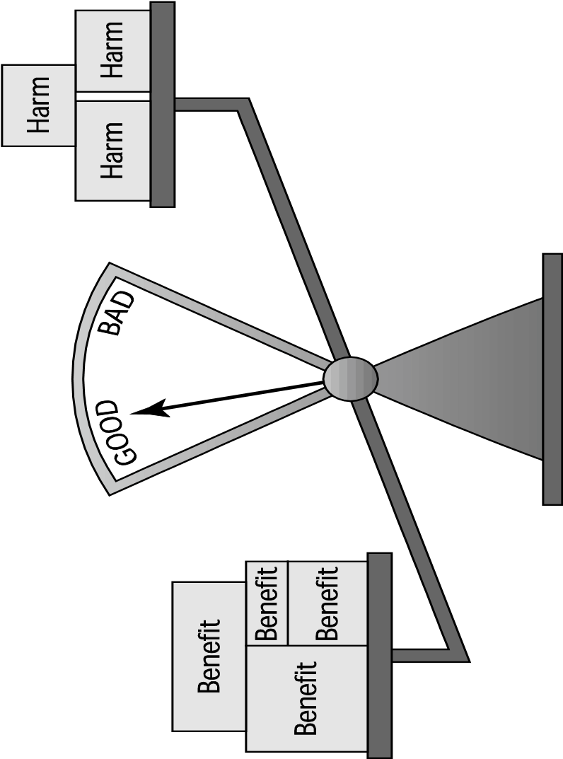Self interest can lead to immoral behavior. Doing good to others lead to happier lives. Not compatible with ethical point of view (cases Against). Not workable
* Act Utilitarianism • Utilitarianism focuses on the consequences and not on intent.

•• More benefits than harm: action is good, happy, pleasurable More harm than good: action is bad, costly, evil, painful

* Uses principle of utility: Right increases happiness and wrong decreases happiness of all affected parties.

# Act Utilitarianism

* Arguments for Act Utilitarianism are
  + Practical. Focuses on happiness which we all pursue. – Comprehensive
* Arguments against
  + Requires too much work. (what factors to include, for how long, what cost to assign…)
  + Ignores sense of duty or obligation (keep a promise for example, credibility is critical in the workplace)
* Pledge to help a charity but not follow through after cost/benefit analysis
  + The problem of moral luck (when consequences are not under our control)
* It is our second workable, rational theory.

# Act Utilitarianism

## • Highway routing scenario

* State considers replacing a curvy stretch of highway
  + Highway segment is 1 mile shorter
  + 150 houses would have to be removed
  + Some wildlife habitat would be destroyed
* Should the state go ahead using the principle of utility?
* Evaluate cost an benefits
  + $20 millions to compensate homeowners
  + $10 million to construct the highway segment
  + Lost wildlife habitat is worth $1 million
  + Benefit is $39 million savings in driving costs over life of highway.
* Benefits exceeds costs. Good action by the state

# Ethical Theories

* Rule Utilitarianism

– Turn action into a moral rules that, if followed by everyone, will lead to increase in total happiness

* Act Utilitarianism applies principle of utility to individual actions
* Rule Utilitarianism applies principle of utility to moral rules
* Like Kantianism, it focused on rules

* Arguments for include
  + Easier to perform.
  + Moral rules survive exceptional situations (sending flower to a sick in a hospital).
* Arguments against
  + Hard to quantify some actions (wildlife habitat…)
  + Conflict may arise between principle of justice and principle of utility

# Rule Utilitarianism

## • Anti-Worm Scenario

* In August 2003, Blaster worm infected thousands of windows computers. It caused a reboot every few minutes.
* Soon after, Nachi worm was released to take control of computers infected and destroy Blaster. But it also used computer as launching pad to look for other computers. Is releasing Nachi a good action?

• The moral rule used by whoever released Nachi is that If I can write a helpful worm, I should do so.

* It helps people who do not protect their computers. However, if applied as a rule, networks would slow down
* System administrators, would be harmed by having to spend more time fighting worms (even good worms may have bugs).
* Harm outweigh benefits. The release of Nachi was wrong.

# Ethical Theories

* Social Contract Theory
  + A social contract with moral rules governing relations among citizens. Government enforces the rules (Thomas Hobbes in 1600’s)
  + People should have basic rights (John Locke)
  + No one is above the rules prevents society from enacting bad rules

(Jean-Jacques Rousseau in the 1700’s)

* + Like Kantianism, it is based on universal moral rules derived through rational process.

* + Arguments for include
* Uses language of Rights and contracts/agreements
* Provides clear analysis of certain citizen or government problems (jail)

– Arguments against

* Conflicting rights problems (abortion)
* May unjustly treat people who cannot uphold contract (hungry stealing to eat)

# Ethical Theories: Social contract

* John Rawls’s Principles of Justice
  + Each person may claim a “fully adequate” number of basic rights and liberties, so long as these claims are consistent with everyone else having a claim to the same rights and liberties

* + Any social and economic inequalities must satisfy that
* Everyone has a fair and equal opportunity to achieve
* Be to the greatest benefit of the least-advantaged members of society (the difference principle)

# Social Contract

## • Kinds of Rights

* Negative right: A right that another can guarantee by leaving you alone (free expression)
* Positive right: A right obligating others to do something on your behalf (education K-12)
* Absolute right: A right guaranteed without exception

(right to life)

* Limited right: A right that may be restricted based on the circumstances (higher education)

• Positive rights tend to be limited • Negative rights tends to be more absolute

# Social Contract

* Rights are considered to be ethically correct and valid since a large or ruling population endorses them.
* Individuals may also bestow rights upon others if they have the ability and resources to do so.

* Social contract theory is our fourth workable ethical framework to use in analyzing an ethical situation.

Virtue Ethics is about character

* Kantianism, utilitarianism, social contract theory focus on
  + Actions (single or rule)
  + Consequences, duties, rights

* Virtue ethics considers
  + Moral wisdom
  + Family and social relationships
  + Emotions
  + Moderation

R. Mezenner Chapter 9:Professional Ethics 22

# Virtue Ethics

* Aristotle – Happiness results from living a life of virtue
* Intellectual virtue: developed through reasoning (applying science/art) • Moral virtue: developed by repeating virtuous acts (virtues)
* Some virtues: courage, fairness, generosity, honesty….

– Deriving pleasure from a virtuous act is a sign that the virtue has been acquired (a skill that can be acquired)

• Virtue Ethics is based on imitation of moral examples (persons of strong moral character).

* + possesses and lives out many virtues
  + knows right thing to do in many situations

– Character traits used to decide what is right

R. Mezenner Chapter 9:Professional Ethics 23

# Virtue Ethics

* Provides a balanced approach.

– Often, a virtue is situated between two extremes (vices)

* Courage between cowardliness and rashness
* Generosity between stinginess and prodigality
* Provides a solution to impartiality
  + Some virtues are partial (e.g., generosity)
  + Other virtues are impartial (e.g., fairness)
  + Weakness
* Does not provide a process for decision making
* May undermine attempts to hold people responsible

• It is a workable theory and is a good complement to other workable theories (utilitarianism)

Chapter 9:Professional Ethics

## Comparing Workable Ethical Theories

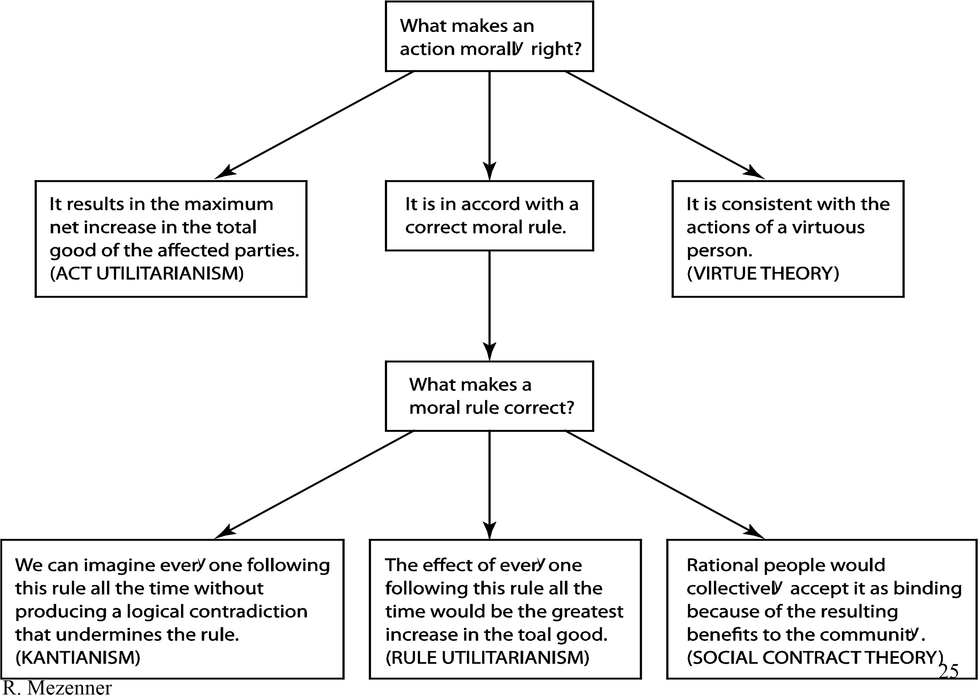

Morality of Breaking the Law

* Under social contract theory (Abiding by the law)
  + Legal system is supposed to protect people’s rights
  + Everyone bears certain burdens in order to receive certain benefits
  + Should only break law to follow a higher order moral obligation
* Under Kantianism (contradiction)
  + I may break a law I believe to be unjust. Laws would become subverted if everyone uses that rule

* + Contradiction: wish to be treated justly and allow laws to be subverted.
* Under Utilitarianism (Harm greater than benefits)
  + Benefit: happiness of people doing what they please
  + Harms: Loss of respect for laws, increased burden on justice system. Harm to people affected by lawless actions.
  + Act Utilitarianism may justify breaking a law (give a poor person a copy of a CD).

## Summary

* Kantianism: categorical imperative (First and/or second formulation)

– Can the moral rule be a universal law without contradiction? – Are we using people as a means to an end?

* Utilitarianism: You should consider the consequences of an action before deciding whether it’s right or wrong

(Principle of utility: Harms and benefits to all stakeholders). Act and/or rule utilitarianism.

* Social contract theory: We should promote collective rights and the principle of justice. Honor laws and contracts.
* Virtue theory: Does the act helps us acquire a virtue?

Homework #2

* On e-learning